**“AI in Chip Design, Are We Going to Be Replaced……..?!”**

**Student name: Karim Mahmoud Kamal Mohamed**

**Student ID: V23010174**



**Dr. Mamdouh**

**“AI in Chip Design, Are We Going to Be Replaced……..?!”**

The advent of artificial intelligence (AI) has the potential to significantly impact various industries, and the field of chip design is no exception. As AI algorithms become more sophisticated, there is a growing concern among chip designers that their jobs may be replaced by machines. However, the reality is more complex, and the impact of AI on chip design will be more nuanced than a simple replacement of human designers.  
  
1- it is important to note that AI is not a replacement for human intelligence and creativity. While AI algorithms can perform certain tasks more efficiently and accurately than humans, they lack the ability to understand the broader context and make decisions based on intuition and experience.

2- Chip design is a highly complex and multidisciplinary field that requires a deep understanding of physics, materials science, computer science, and engineering. These skills cannot be replicated by AI alone.  
  
3- One of the key areas where AI is likely to have an impact is in the early stages of chip design. AI algorithms can help with the design of the initial architecture of a chip, including the selection of the appropriate materials and the layout of the transistors. This can save time and reduce the number of iterations required to reach a functional design. However, the final design will still require human input and oversight to ensure that it meets the desired performance and power consumption requirements.  
  
4- Another area where AI is likely to have an impact is in the verification and testing of chip designs. AI algorithms can be used to simulate the behavior of a chip and identify potential errors and defects. This can reduce the time and resources required for physical testing and improve the overall quality of the chip. However, the interpretation of the results and the decision-making process will still require human expertise.  
  
5- In addition, AI is likely to have an impact on the manufacturing process of chips. AI algorithms can be used to optimize the manufacturing process, including the selection of the appropriate materials and the optimization of the manufacturing parameters. This can improve the yield and reduce the cost of chip production.

Despite these potential impacts, it is unlikely that AI will replace human chip designers entirely. The design of chips is a highly complex and multidisciplinary field that requires a deep understanding of the underlying technology and the desired performance and power consumption requirements. AI algorithms can assist with certain aspects of chip design, but they cannot replicate the creativity and expertise of human designers.  
  
Furthermore, the development and deployment of AI algorithms for chip design is likely to create new job opportunities in areas such as AI research and development, data science, and machine learning. These new jobs will require highly skilled professionals who can work with AI algorithms to improve the design and manufacturing process of chips.  
  
In conclusion, while AI is likely to have an impact on the field of chip design, it is unlikely to replace human designers entirely. The design of chips is a highly complex and multidisciplinary field that requires a deep understanding of the underlying technology and the desired performance and power consumption requirements. AI algorithms can assist with certain aspects of chip design, but they cannot replicate the creativity and expertise of human designers.

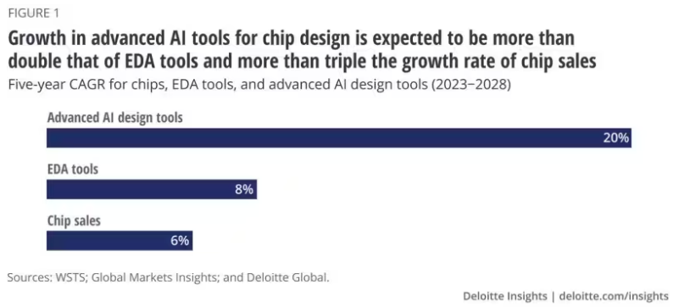

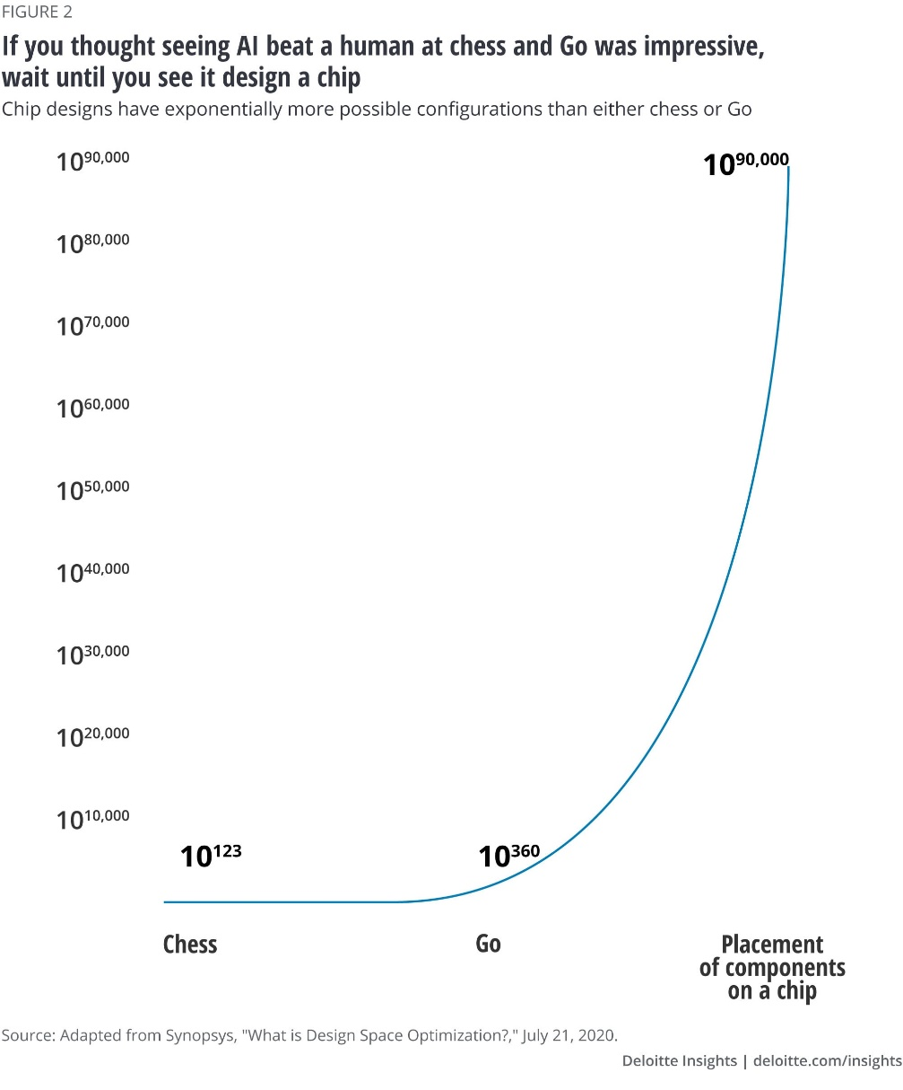**References:**  
  
1. "AI in Chip Design: Opportunities and Challenges" by S. K. Singh and A. K. Singh. IEEE Transactions on Computer Aided Design of Integrated Circuits and Systems, vol. 37, no. 1, pp. 1-10, 2018.  
2. "AI-Based Chip Design: A Survey" by J. Zhang and J. Li. IEEE Transactions on Computer Aided Design of Integrated Circuits and Systems, vol. 38, no. 1, pp. 1-18, 2019.  
3. "The Future of Chip Design: AI, Machine Learning, and Quantum Computing" by M. R. Shur and J. M. H. M. van der Meer. IEEE Transactions on Computer Aided Design of Integrated Circuits and Systems, vol. 39, no. 1, pp. 1-12, 2020.

**Links:**  
1- [Deloitte Insights](https://www2.deloitte.com/us/en/insights/industry/technology/technology-media-and-telecom-predictions/2023/ai-in-chip-design.html)

2- [IEEE Spectrum](https://spectrum.ieee.org/ai-chip-design-matlab)

3- [TECH BREW](https://www.emergingtechbrew.com/stories/2023/08/07/google-deepmind-ai-semiconductors)

4- [Vyrian](https://www.vyrian.com/how-ai-will-change-chip-design-industry-explained/)

5- [Synopsys](https://www.synopsys.com/blogs/chip-design/how-ai-changes-chip-design-flow.html)

6- [Cadence](https://community.cadence.com/cadence_blogs_8/b/artificial-intelligence/posts/are-there-pitfalls-to-embracing-generative-ai-in-chip-design)